HABITS OF A MULTIPLYING DISCIPLE: PRAY

DISCUSSING & APPLYING JOHN 15:1-8
Have one person read their paraphrase of the passage.
- What stood out to you from John 15:1-8?
- How do we “remain” or “abide” in the Lord?
- What did God invite you to do personally? (Your “I will…”) How did it go?
- How did it go doing a prayer walk with one or two others?

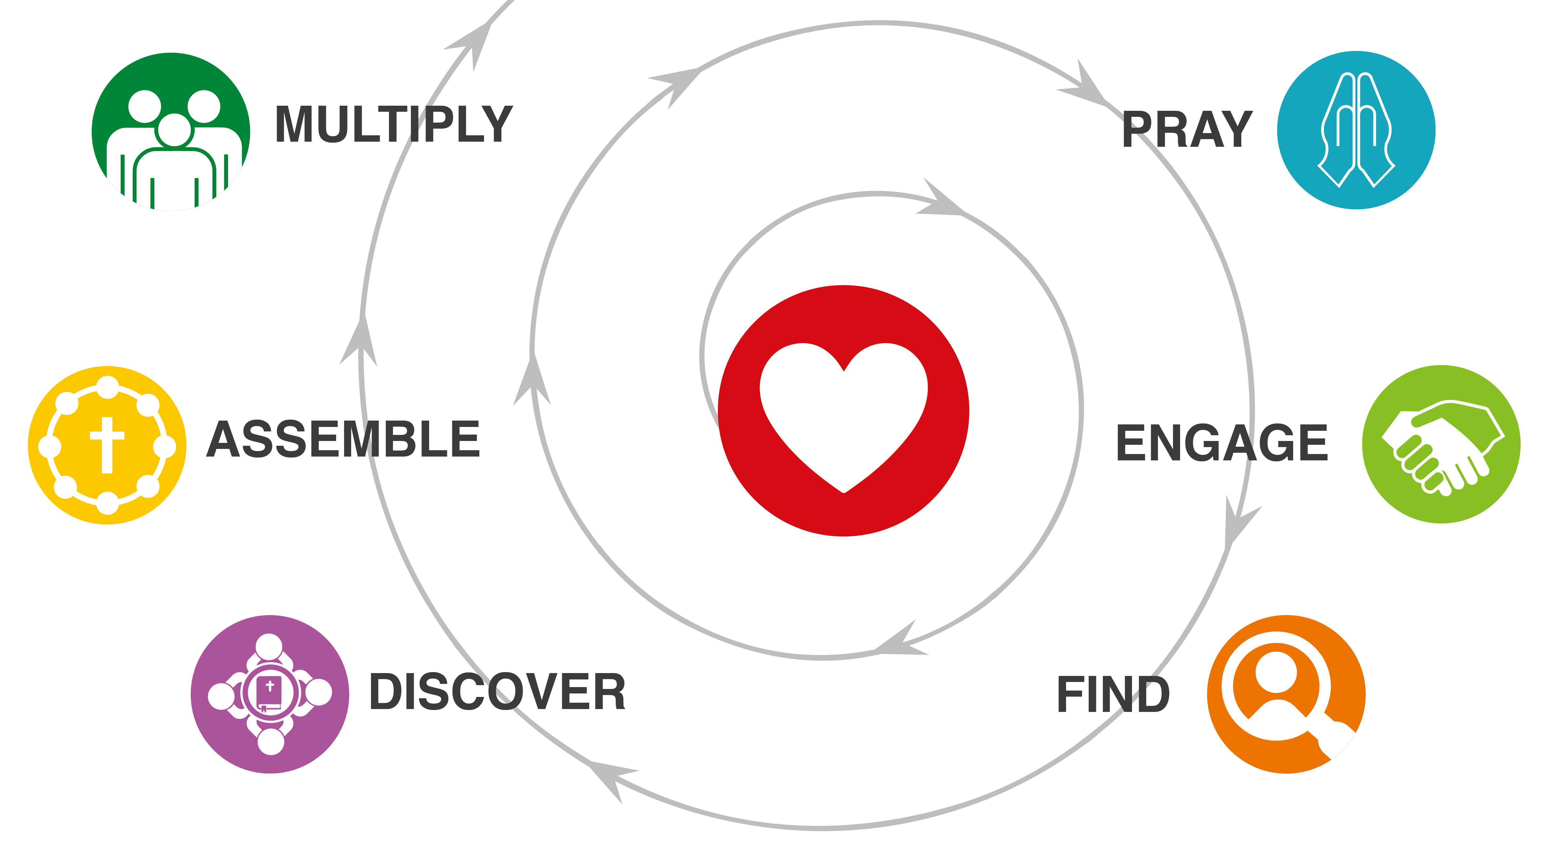
HABITS OF DISCIPLE MAKING
The habits begin in God’s heart of love for a lost world. His call to make disciples moves us to pray. We then grow in the habits.
- Making disciple makers
- Mentoring disciple makers
- Multiplying churches, then movements happen
You can draw the habits on a napkin!

WHAT DOES JESUS TEACH US ABOUT ABIDING AND BEARING FRUIT?
Read John 15:9-17 aloud. Then read it again.
- Paraphrase the passage.
- As a group make sure the entire passage is reflected in the paraphrase. (Was anything added? Was anything left out?)
- What do you observe about fruit bearing and abiding?

EXTRAORDINARY PRAYER IN DISCIPLE MAKING MOVEMENTS
There are many ways to add “extra” to your “ordinary” prayer, individually and as teams.
- 10:02 Prayer (praying Luke 10:2 daily at 10:02 AM and/or PM)
- 30-Day Prayer calendar
- Prayer Walking and Team Prayer Times
- Fasting (personally and with others)

YOUR ASSIGNMENT
- Do a 3-Column Study on Deuteronomy 6:4-9.
- Add something “extra” to your “ordinary” prayer this week.
- Ask 3 people if you could pray for them. Questions you could use:
  - Is there anything I could pray for you about?
  - If God could do something amazing in your life, something like a miracle, what would it be? Can I pray that he would do that for you?

What does it say?
(Write the text word-for-word.)

What does it mean?
(Write it in my own words.)

What must I do to obey?
(My “I will…” statement.)

With whom will I share?

